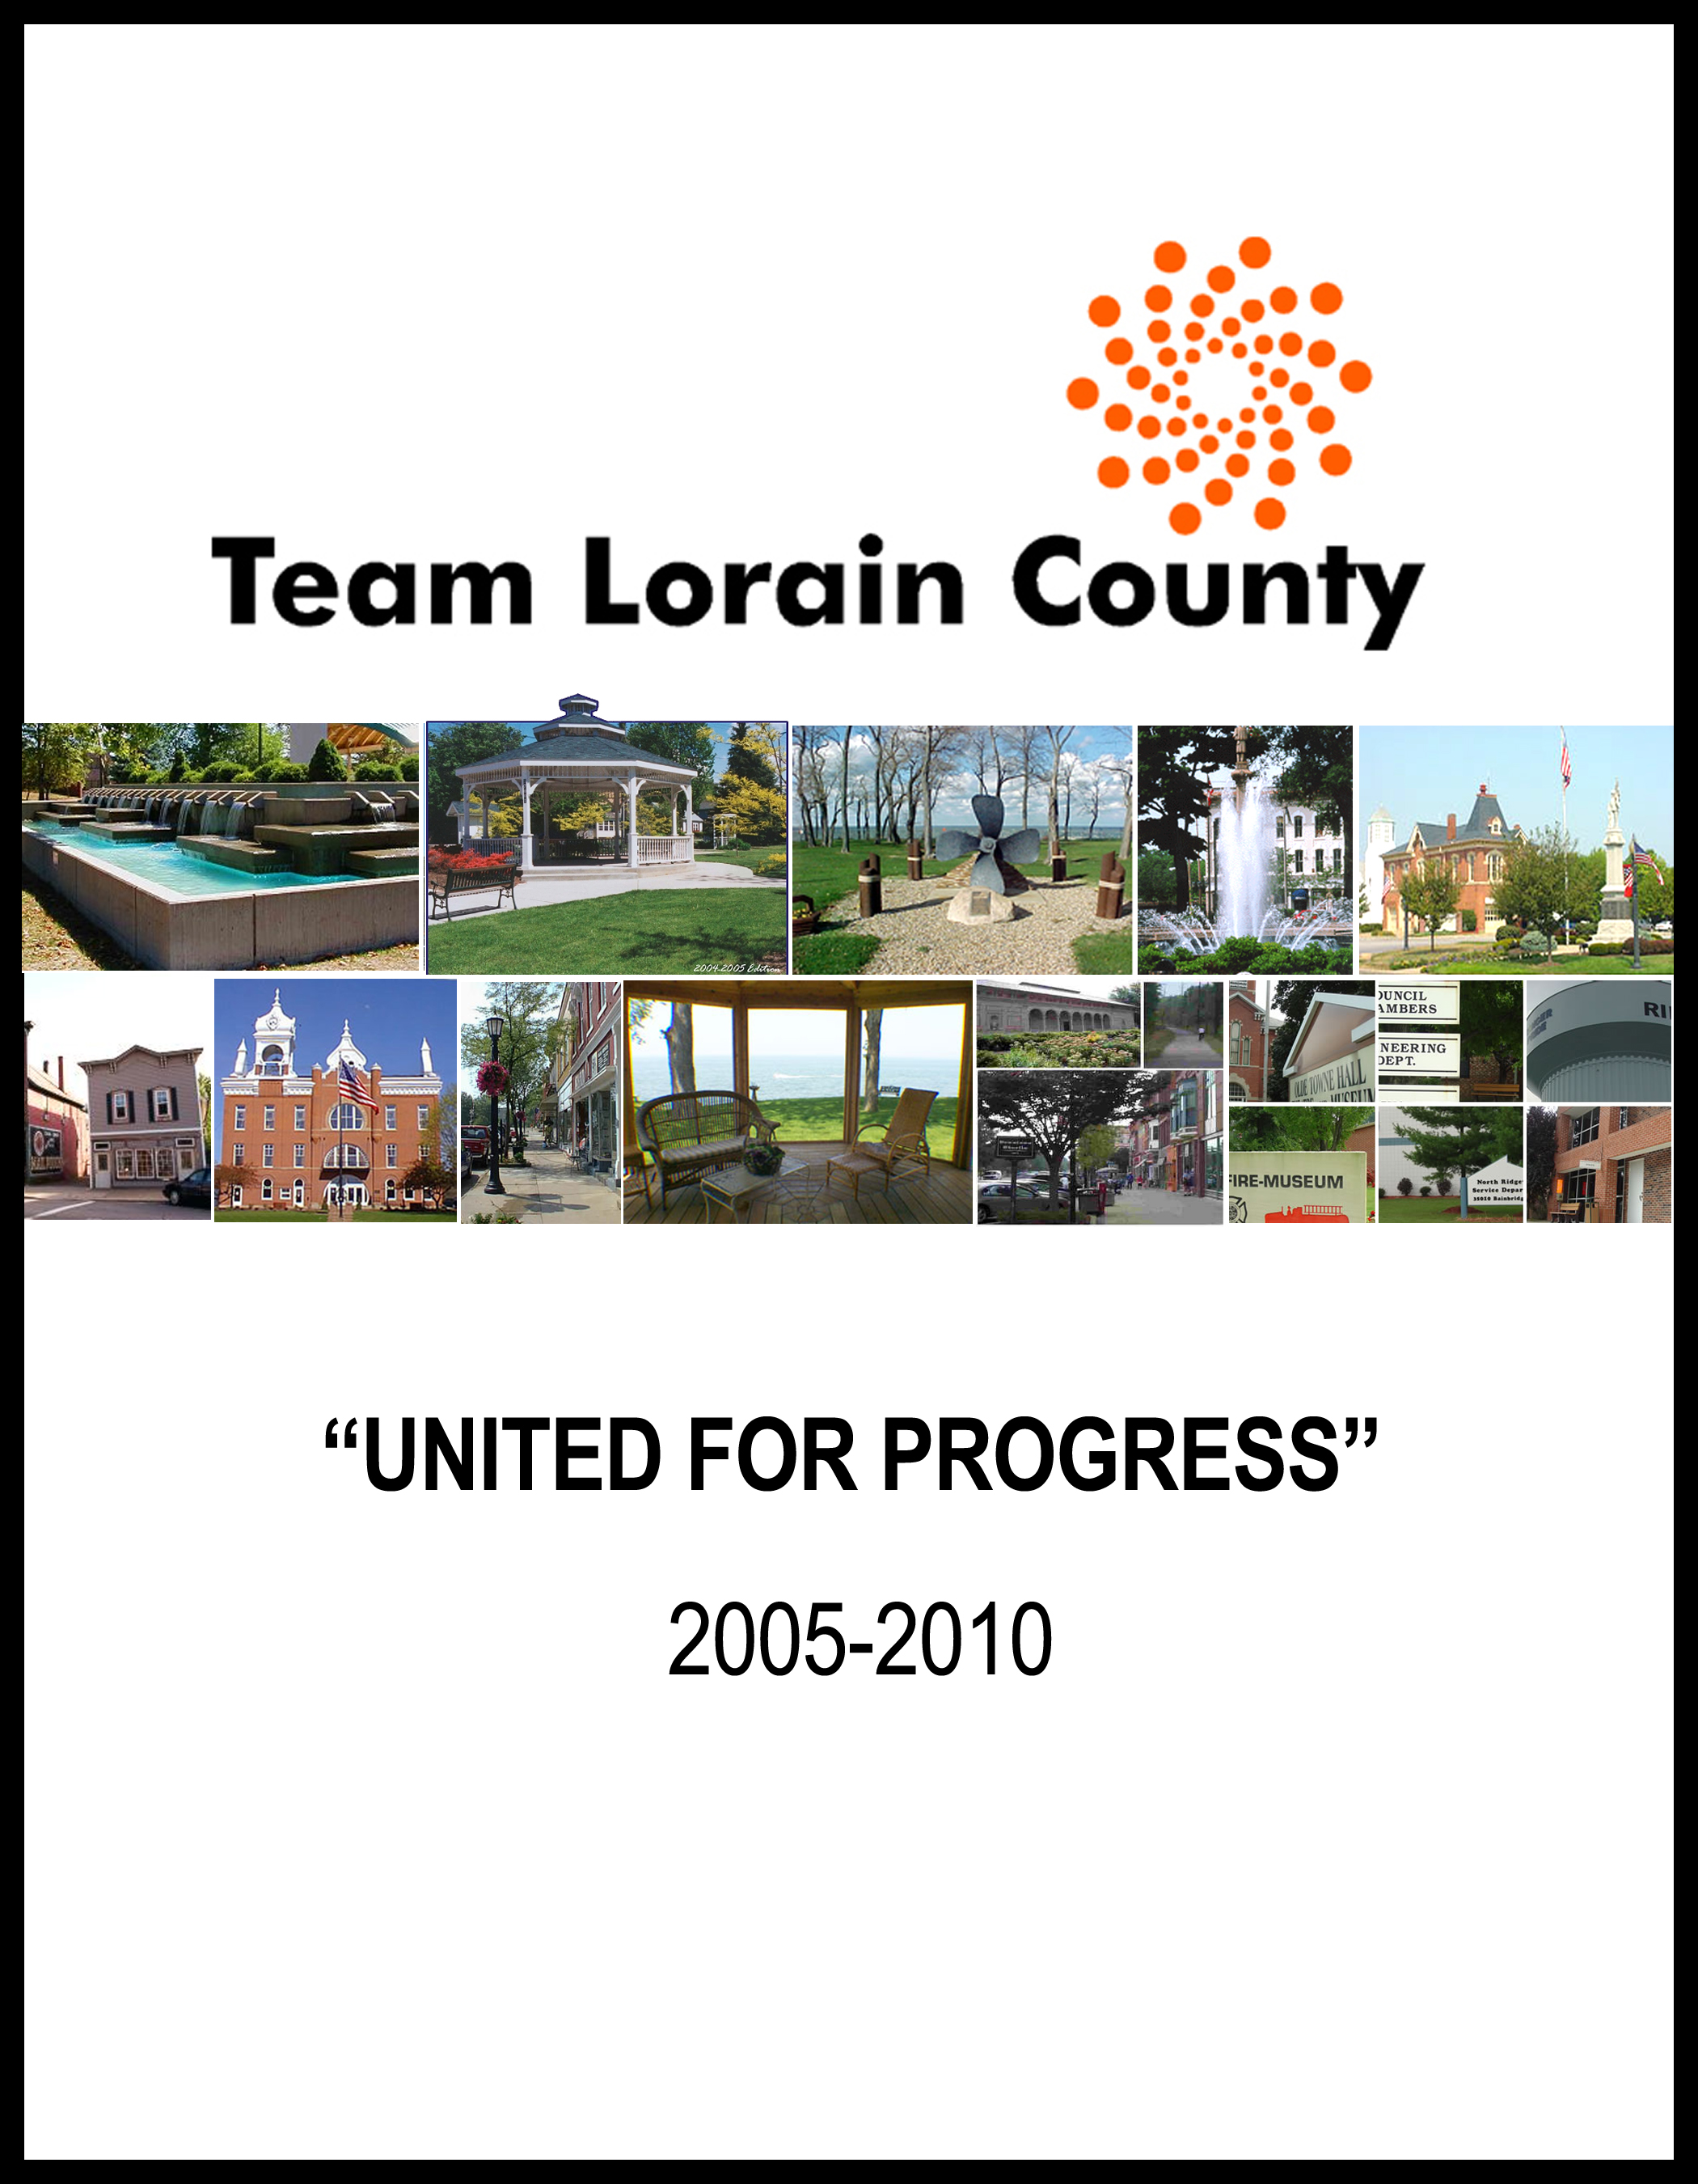

Gerald B. Blouch | Edward P. Campbell
Invacare Corporation | Nordson Corporation
Dr. Roy A. Church | Jim Cordes
Lorain County Community College | Lorain County
Maureen Cromling | Kevin J. Flanigan
Ross Environmental, Inc. | General Plug and Manufacturing
Brian R. Frederick | James F. Kidd
The Community Foundation of  Greater Lorain County | Lorain National Bank
William G. Lamb | Kevin C. Martin
FirstMerit Bank | EMH Regional Medical Center
Jack Matia
Matia Chevrolet

LORAIN | ELYRIA
Richard Colella …..Colella & Weir, PLL | Joe Faga ……………………Ohio Edison
Daniel Cwalina… .LorMet Credit Union | Terry Goode ….Lorain County Title Co.
Craig Foltin …………………….. Mayor | Wiliam Grace …….………………Mayor
Tim Kissane …………………CenturyTel | Cooper Hudnutt …..Chronicle Telegram
Brian Lockwood …..…….………...CHP | Lynn Miggins…...….…….KS Associates
Jeff Riddell ..Consumers Builders Supply | Kurt A. Raicevich....….Fifth Third Bank
Billy Rowland....….Rowland Enterprises
Jeff Sudrook…...... The Morning Journal
Larry Goodman…....Goodman Beverage
NORTH RIDGEVILLE | AMHERST
G. David Gillock ..………….……Mayor | David A. Taylor……….…..……..Mayor
 | Kim Mulder…….………….Star Builders
SHEFFIELD VILLAGE | SHEFFIELD LAKE
Darlene Ondercin...…..….……… Mayor | John Piskura ……………...………Mayor
AVON | AVON LAKE
David Herzer .. Wickens, Herzer, Panza, Cook & Batista | Rob Berner ………………………..Mayor
Rose M. Jenne……… Jenne Distributors | Bucky Kopf ……………… Kopf Builders
James Smith …………………….. Mayor | Clif Moorehead... Ford Motor Company
 | Dennis Cocco…....PolyOne Corporation
OBERLIN | WELLINGTON
Robert DiSpirito ……...….City Manager | John Cloud ......Forest City Technologies
Alan Moran……………. Oberlin College | Bob Dupee…..….. Village Administrator
GRAFTON | VERMILION
Sherry Kerner...…..……..………..Mayor | Jimmy Davis………..……….……Mayor
Rick Kowalski ..…Village Administrator | Jim Herrick…....….Liberty Auto Group
LAGRANGE | LORAIN COUNTY
Kim Strauss..…………...……..…Mayor | William Randall……Lorain County JVS
 | Bruce Stevens………….….Buckeye Bank

“Creation of Community Wealth”
Progressive communities acquire wealth by utilizing all available resources of a market including fiscal, natural, human, private, governmental and all others to enhance the economic security and quality of life of its residents.
There are two primary goals of an economic development program:
- Increase the flow of money into a community
- Retard the flow of money out of a community
By accomplishing these two goals, the entire economy of an area is enhanced as the total wealth in the community increases, benefiting all citizens.

TEAM LORAIN COUNTY

- Protect and support the existing employment base.
- Support local workforce development programs.
- Aggressively market Lorain County to foster new investment and high quality job creation.
- Encourage development of appropriate infrastructure.
- Improve the quality of life for the residents of Lorain County.

5-YEAR GOALS

5,000 NEW, HIGH QUALITY JOBS

$150 MILLION IN NEW PAYROLL

$250 MILLION IN NEW CAPITAL INVESTMENT

In response to increased global competition, changing economic conditions and the loss of manufacturing jobs, the TEAM LORAIN COUNTY organization has been created to implement a coordinated, countywide economic development program designed to strengthen and grow Lorain County’s economy by fostering quality job creation.

A year long planning process was undertaken to ensure that the right economic development program is implemented in 2005 which will deliver important support services to local companies in communities throughout Lorain County now and into the future. This process included:

- Program assessment interviews with 70+ business and community leaders during the 1st quarter of 2004, followed by;
- Two Countywide Visioning Sessions held in June 2004 attended by more than 120 business and community leaders, followed by;
- Three Consensus Building Sessions in August 2004, attended by 50+ leaders, to finalize our organizational and programmatic strategies.

SUMMARY

There is broad-based consensus among business and community leaders throughout Lorain County to create a pro-active, countywide organization called TEAM LORAIN COUNTY which will implement and execute and focused and results driven economic development program. The mission is to foster economic growth and local job creation while positioning Lorain County to aggressively compete for new jobs and investment.

LORAIN COUNTY ECONOMIC DATA & TRENDS
 | 2000 | 2001 | 2002 | 2003
Population | 284,664 | 286,824 | 288,984 | 291,164
Labor Force | 141,500 | 143,200 | 141,900 | 143,700
Per Capita Income | $26,809 | $27,094 | $26,964 | $26,592
Unemployment | 5.1% | 5.6% | 7.1% | 7.3%
Sales Tax (millions) | $11.4 | $12.9 | $13.6 | $13.7
Housing Permits | 1,784 | 1,631 | 2,123 | 2,262
Industrial Tax Value (000,000’s) | $193.8 | $192.6 | $196.4 | $201.2
Commercial Tax Value (000,000’s) | $597.4 | $617.8 | $646.5 | $659.3
Residential Tax  Value (000,000’s) | $3,444.7 | $3,541.0 | $3,674.8 | $3,890.2

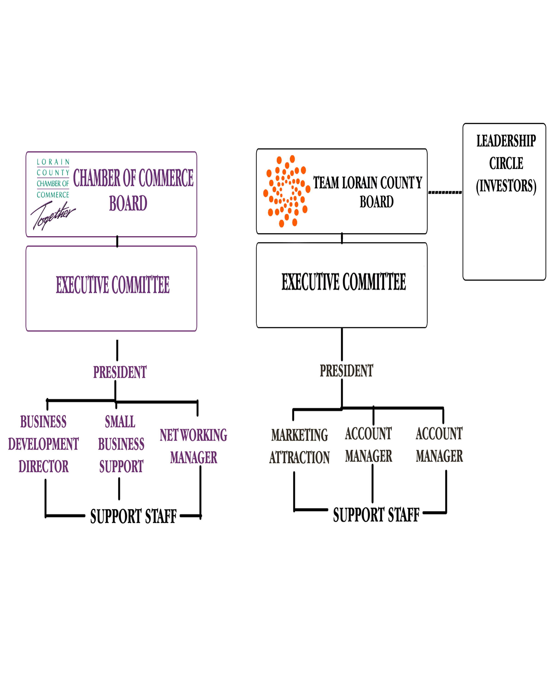

The “UNITED FOR PROGRESS” Campaign is a five-year, $3.75 million funding effort, designed to enhance Lorain County’s ability to compete effectively for quality jobs and new capital investment. Our new program of work will be concentrated in the following strategic areas:

EXISTING INDUSTRY SUPPORT – EXPANSION ASSISTANCE
- Corporate calling program – Synchronist R&E Program
- Small Business Development & Support
- Project financing assistance
- Government Procurement
- State/local incentive programs
- Wage & benefit surveys
- Downstream supplier recruitment
- Manufacturer’s Roundtable

MARKETING
- Marketing and promoting Lorain County
- National and regional advertising
- Direct and electronic mail campaigns
- Direct outreach to economic development network partners
- Trade show attendance
- Website – featuring community profiles, industrial parks, buildings
- Media/Public Relations

NEW BUSINESS RECRUITMENT
- Liaison with Ohio Department of Development &
Partner with Team Northeast Ohio
- Proactive industrial prospect lead generation
- Coordinate site/facility tours
- Provide prospect information packages

SPECIAL PROJECTS
- Participation in the Automotive Communities Program

Goal: Effectively promote Lorain County to enhance our image as a preferred and strategic business location. Significantly increase the growth of quality jobs and capital investment within our County through aggressive new business recruitment strategies.

TEAM LORAIN COUNTY will serve as the lead economic development organization promoting and marketing the advantages of locating businesses in our County. TLC will implement the following strategies:

- Execute an aggressive marketing campaign to include advertising, direct mail and public relations;

- Develop top quality printed collateral material and enhanced web-site technology to deliver regional economic development information.

- Strengthen our relationships with the State and regional economic development organizations, site consultants and other major networks of influence and lead referrals. Leverage these relationships to recruit targeted business clusters including high technology, automated manufacturing, distribution and value-added suppliers.

- Engage the local business network to further target and identify downstream supplier attraction opportunities and new business leads.

- Increase new qualified business leads through direct mail campaigns, attendance at targeted industry trade shows, print advertising and site consultant presentations.

- Develop and maintain an industry-leading prospect response and handling system.

- Develop enhanced data systems and research capability that provide current and accurate information to support decision making of business leaders and site consultants.

Goal: To ensure that a countywide business retention and expansion program is successfully executed throughout Lorain County. TLC will work to promote a stronger business environment by facilitating expansion efforts of local employers, thus reducing the potential relocation, while stimulating new local business expansion and job growth.

- Execute a comprehensive corporate calling program on targeted businesses located throughout Lorain County.

- Create and facilitate a Manufacturer’s Roundtable to strengthen the local network of manufacturing executives and facilitate access to programs including: Lean Process, Quality Assurance, Safety, Supply Chain Management, Government Procurement, Legislative Updates, Export assistance, etc.

- Provide local firms with project packaging, technical assistance and coordinated delivery of expansion support services including:

- Transportation/infrastructure issues
- Financing programs (Tax Exempt Bonds, Loans, IRB)
- New state & local incentive programs
- Wage & Benefit surveys
- Government Procurement Program
- Site and building location assistance

Goal: To ensure a seamless network of local economic development
service delivery of value-added programs to existing businesses and new prospective companies throughout Lorain County.

- Create and fully utilize a modern One Stop Center to facilitate and support local business expansion and new business recruitment activities.

- Participate as an active member in the Center for Automotive Research organization to ensure Lorain County is well positioned to support Ford Motor Company and its downstream suppliers.

- Serve as the central resource center for information and data to support economic development activities. Maintain a comprehensive database of all industrial sites and buildings throughout Lorain County.

- Provide ongoing support services to local units of government and public sector officials in data gathering, proposal development and client handling.
TLC
Existing Industry Support

Liaison with State of Ohio
New Business
Recruitment

Local Partner of TEAM NEO

Site/Building Database
Manufacturer’s Roundtable
Incentive Programs

One Stop Resource Center
Marketing Lorain County

New Business Recruitment | $275,000
Existing Industry Support | $185,000
Marketing Lorain County | $165,000
Special Projects Fund | $ 60,000
One Stop Resource Center | $ 40,000
Issue Advocacy | $ 25,000
Total | $750,000

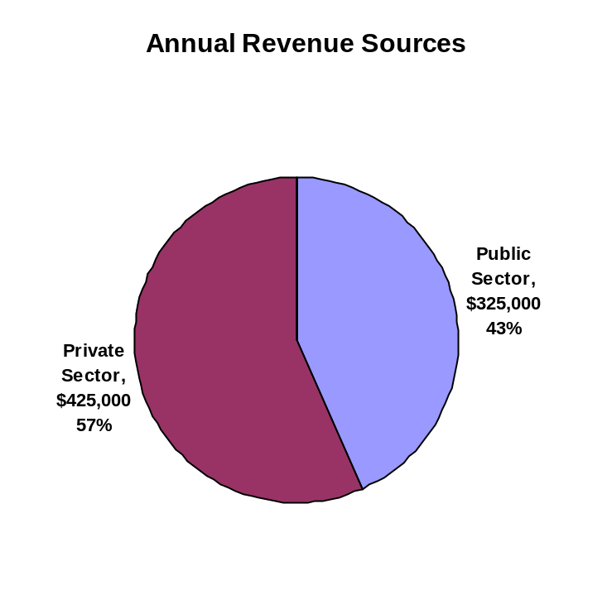 | 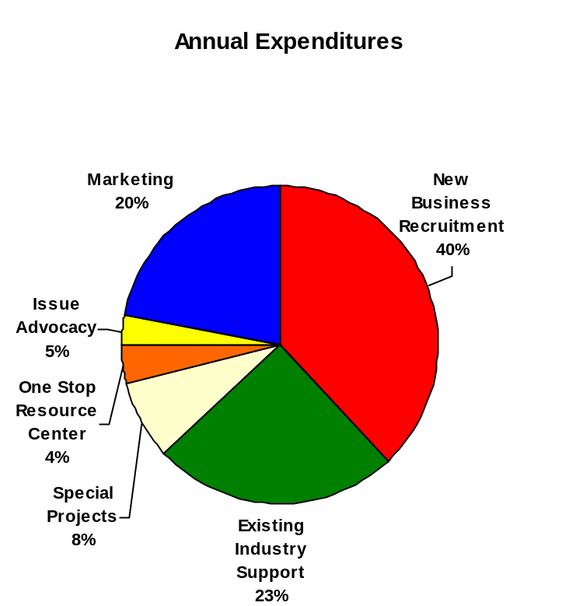

Average Annual New Jobs Goal: 1,000 Base Jobs

Targeted New Job Wage Level: $30,000

1,000 New Base Jobs @ $30,000 = $30,000,000
1,000 New Indirect Jobs @ $15,000 = $15,000,000
Total Gross Annual Earnings = $45,000,000

Total Net Annual Earnings (75%) = $33,750,000

CPI-U Categories Percentage Annual Expenditures

Housing – Mortgage 22.30% $7,526,250
Grocery Stores 8.60% $2,902,500
Restaurants 6.80% $2,295,000
Housing – Rent 6.70% $2,261,250
Recreation/Entertainment 5.90% $1,991,250
Housing – Furnishings 4.90% $1,653,750
New Vehicles 4.90% $1,653,750
Retail – Apparel 4.50% $1,518,750
Gas & Electricity 3.50% $1,181,250
Personal Care 3.40% $1,147,500
Auto Gasoline 3.20% $1,080,000
Medical Care – Dr. Services 2.80% $ 945,000
Telecommunications 2.80% $ 945,000
Education – Tuition/Fees 2.60% $ 877,500
Used Cars & Trucks 2.10% $ 708,750
Vehicle Parts & Maintenance 1.80% $ 607,500
Misc. Personal Services 1.80% $ 607,500
Hospital Services 1.70% $ 573,750
Medical Care – Commodities 1.60% $ 540,000
Alcoholic Beverages 1.30% $ 438,750
Public Transportation 1.20% $ 405,000

Tobacco Products .90% $ 303,750
Water/Sewer/Rubbish .70% $ 236,270
Housing Insurance .60% $ 202,500
100% $33,750,000
SOURCE: U.S. Department of Labor – Bureau of Economic Analysis

Existing Industry Program 2005 2006 2007 2008 2009
# of local company visits
# of support packages
# of financial packages
# of expansion projects completed
# of expansion jobs created
# of existing jobs retained
# on expansion jobs created
New capital investment
Expansion tax base increase

New Business Recruitment
# of trade shows attended
# of direct mailings
# of recruitment visits
# of ODOD leads received
# of Team NEO Leads received
# of internal leads generated
# of new prospect inquiries
# of prospect tours/site visits
# of companies located
# of new jobs created
AEPW of new jobs
New capital investment
New tax base created

Marketing/Image Enhancement
# of newsletters produced
# of articles released to media
# of ad placements

Special Projects
# of grant applications made
# of grants awarded

OFFICERS

Richard J. Collela Joseph N. Faga Kevin J. Flanigan
Colella & Weir, PLL Ohio Edison General Plug & Manufacturing

Terry D. Goode Timothy A. Kissane Kevin C. Martin
Lorain County Title CentruyTel of Ohio Elyria Medical Center

Kurt Raicevich
Fifth Third Bank

BOARD MEMBERS

Charles E. Baumgartner ……………………………...…Baumgartner & O’Toole
Betty C. Blair …………………………………………………….Lorain County
Robert M. Campana …………………………………………….P.C. Campana
A.K. Doug Charles……………………………………………….. Del Lumber
Roy A. Church ………………………………….Lorain County Community College
Craig Foltin ………………………………………………………City of Lorain
Mark Gacka ………………………………………………...Nordson Corporation
William M. Grace ………………………………………………..City of Elyria
David L. Herzer ……………………………..Wickens, Herzer, Panza Cook & Batista
Cooper Hudnutt ……………………………………………..Chronicle Telegram
Rose M. Jenne ……………………………………………Jenne Distributors, Inc.
Jim Kidd ……………………………………………………Lorain National Bank
Bucky Kopf ……………………………………………………Kopf Construction
Brian C. Lockwood ………………………………….Community Health Partners
Lynn Miggins ………………………………………………...KS Associates, Inc.
Tony Reinhart ……………………………………………...Ford Motor Company
Mary Siwierka …………………………………………….Lakeland Eye Surgeons
Tim Watson …………………………………………………..WTSN Enterprises

