Community Improvement
Corporation of Henry County

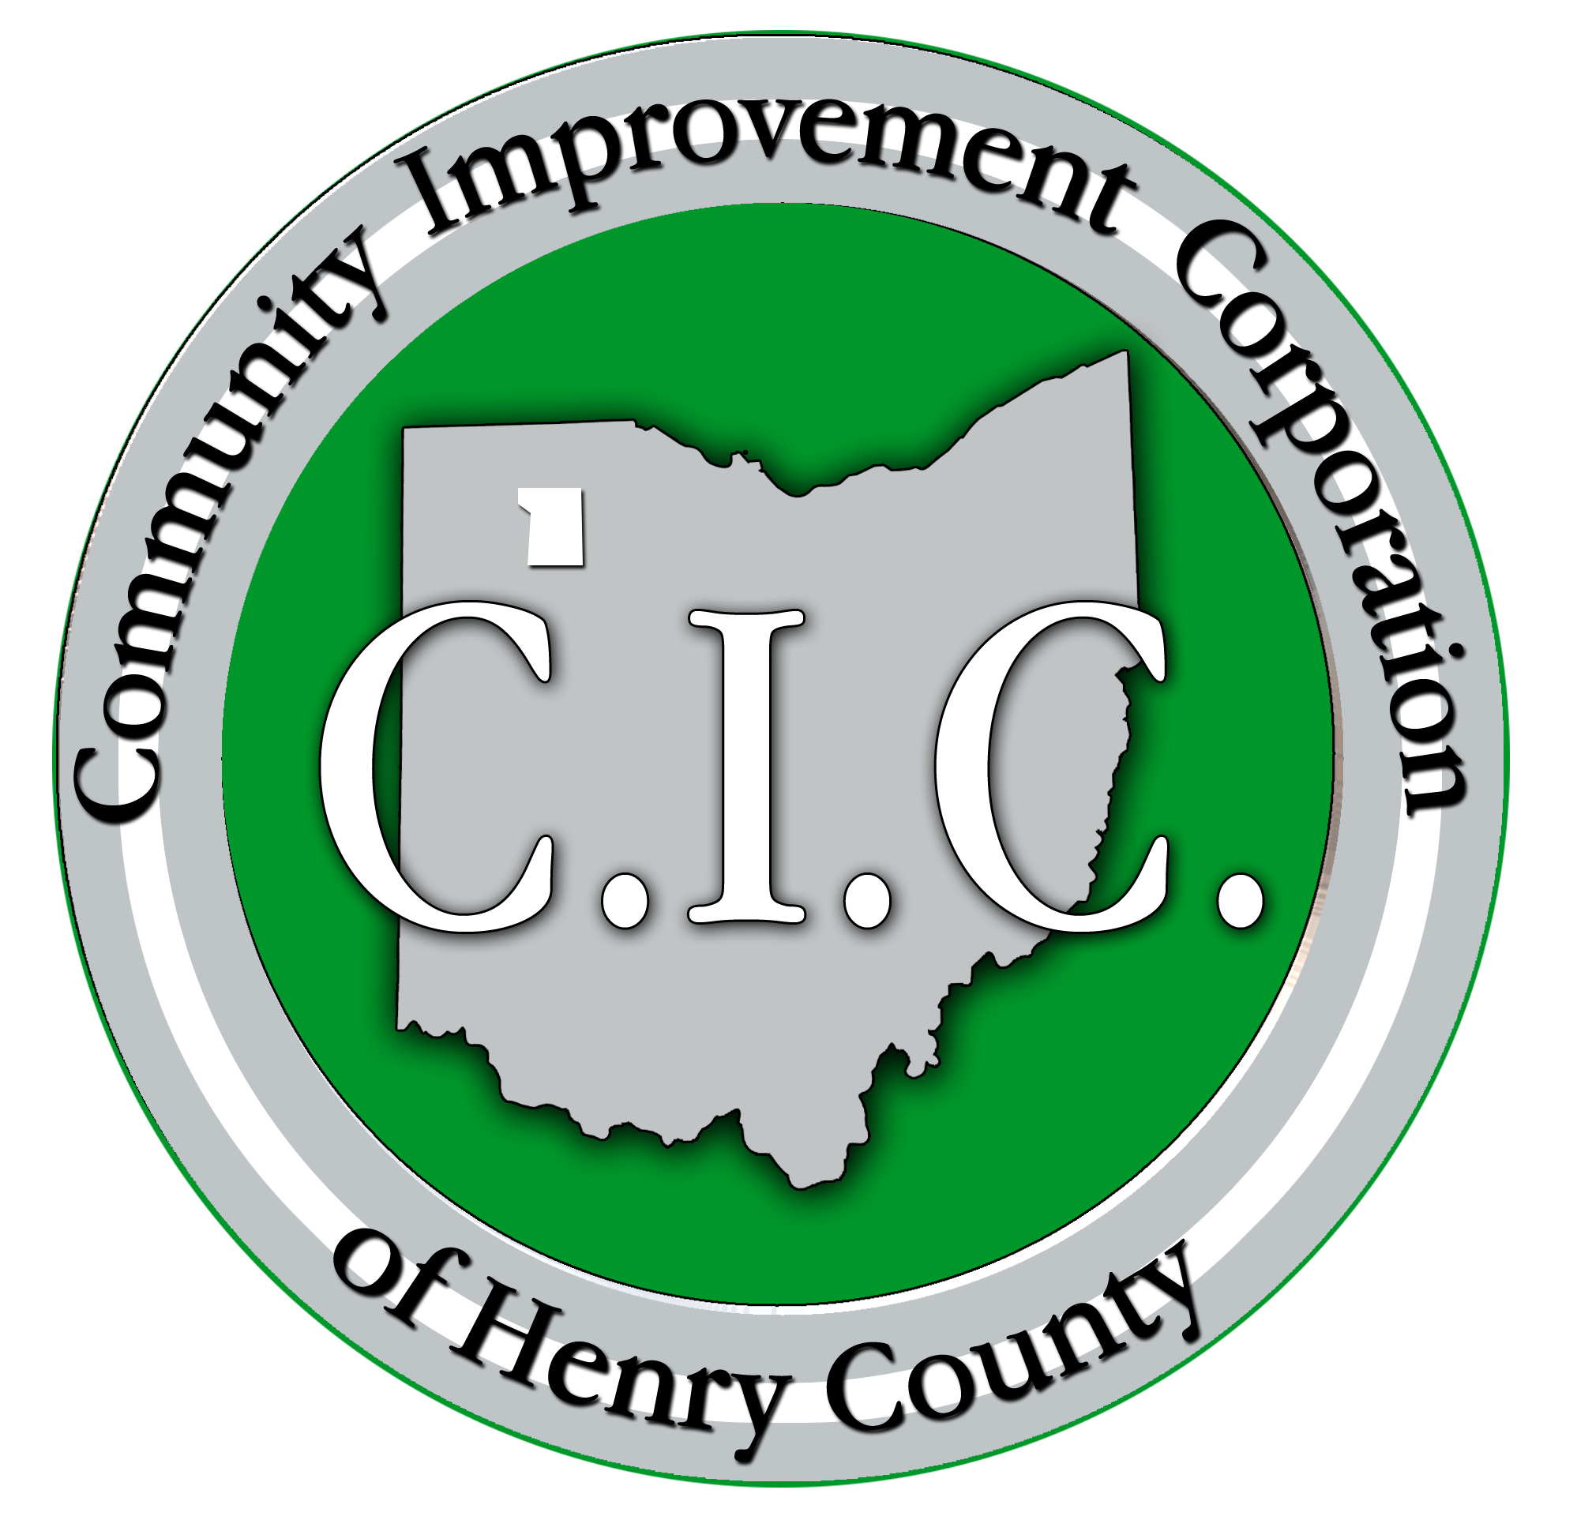

PARTNERING FOR PROGRESS

“DRAFT”

2007 - 2011

CAMPAIGN CO-CHAIRS

Glenn Badenhop | Steve Bischoff | Bob McLimans
Steve McNally | Ray Oldach | Ed Peper
John Sunderman | Dave von Deylen | Bill Wendt

CAMPAIGN ADVISORY COUNCIL

Cheryl Bostelman | Paul Chamberlain | Donelda Drewes
Max Fetterman | Bruce Hesterman | Edward A. Hoeffel
Brian Koehler | Larry Koesters | Tricia Koesters
Rick Kuhbander | Tom Mack | Glenn Miller
Rich Myers | Kevin Nye | Phil Parsons
Chris Peper | Israel Resendez | Richard Rickenberg
John Sagar | J. Andrew Small | Steve Small
Ted Titgemeyer | Terri Williams | Marlow Witt

REGIONAL COMPARISON

How does Henry County compare today?

 |  | Annual
 |  | Econ. Dev. | Public | Private
Ohio Counties | Population | Budgets | Sector | Sector
ALLEN | 108,000 | $500,000 | 50% | 50%
WOOD | 121,000 | $375,000 | 75% | 25%
FULTON | 42,000 | $300,000 | 100% | 0%
DEFIANCE | 39,000 | $290,000 | 40% | 60%
PUTNAM | 35,000 | $200,000 | 50% | 50%
MARION | 66,000 | $250,000 | 75% | 25%
OTTAWA | 40,000 | $260,000 | 92% | 8%
SANDUSKY | 62,000 | $200,000 | 20% | 80%
HENRY | 29,000 | $160,000 | 90% | 10%

How will Henry County compare tomorrow?

 |  | Annual
 |  | Econ. Dev. | Public | Private
Ohio Counties | Population | Budgets | Sector | Sector
ALLEN | 108,000 | $500,000 | 50% | 50%
WOOD | 121,000 | $375,000 | 75% | 25%
FULTON | 42,000 | $300,000 | 100% | 0%
DEFIANCE | 39,000 | $290,000 | 40% | 60%
PUTNAM | 35,000 | $280,000 | 50% | 50%
OTTAWA | 40,000 | $260,000 | 92% | 8%
MARION | 66,000 | $250,000 | 75% | 25%
HENRY | 29,000 | $240,000 | 60% | 40%
SANDUSKY | 62,000 | $200,000 | 20% | 80%

PROGRAM SUMMARY

The “Partnering for Progress” Campaign is a five-year $500,000 private sector funding effort, which when coupled with current public sector funding will adequately fund our ability to compete effectively for quality jobs and new capital investment.

This countywide funding effort will allow the CIC to implement a focused, pro-active program to foster wealth creation in our area. Our new program of work will be concentrated in the following three strategic areas:

I. RETENTION & EXPANSION JOB ASSISTANCE

Goal: To ensure that a countywide business retention and expansion program is successfully executed throughout Henry County. The CIC will work to promote a stronger business environment by facilitating expansion efforts of local employers, thus reducing the potential relocation while stimulating new local business expansion and job growth.

- Execute an ongoing corporate calling program on Henry County businesses.

- Create a Manufacturer’s Roundtable to strengthen the local network of manufacturing executives and facilitate access to programs including: Lean Process, Quality Assurance, Safety, Supply Chain Management, Government Procurement, Legislative Updates, etc.

- Provide local firms with project packaging, technical assistance and coordinated delivery of expansion support services including:
- Transportation/infrastructure issues
- Financing programs (Tax Exempt Bonds, Loans, IRB)
- New state & local incentive programs
- Wage & Benefit surveys
- Government Procurement Program
- Export Assistance

II. MARKETING AND NEW BUSINESS RECRUITMENT

Goal: Effectively promote the Henry County to enhance our image as a preferred and strategic business location. Significantly increase the growth of quality jobs and capital investment within our county through aggressive new business recruitment strategies.

Strategies:
- The CIC will serve as the lead economic development organization promoting and marketing the advantages of locating businesses in Henry County;

- The CIC will execute an aggressive marketing campaign to include advertising, direct mail, attendance at targeted industry trade shows, print advertising and site consultant presentations to increase the volume of new qualified business leads.

- The CIC will develop top quality printed collateral material and enhanced web-site technology to deliver regional economic development and community information.

- Strengthen our relationships with the State and regional economic development organizations, site consultants and other major networks of influence and lead referrals. Leverage these relationships to recruit targeted business clusters including high technology, automated manufacturing, distribution and value-added suppliers.

- Engage the local business network to further target and identify downstream supplier attraction opportunities and new business leads.

- Serve as the central resource center for information and data to support economic development activities throughout the Henry County. Maintain a comprehensive database of all industrial sites and buildings throughout Henry County.
III. COORDINATED DELIVERY OF ECONOMIC DEVELOPMENT SERVICES

Goal: To ensure a seamless and efficient delivery of value-added services to existing businesses and new prospective companies.

Strategies:
- Create and fully utilize a modern One Stop Center to facilitate and support local business expansion and new business recruitment activities.

- Identify opportunities and challenges, which impact our County’s economic health and serve as a neutral forum to foster local collaboration and problem solving.

- Provide ongoing support services to local units of government and public sector officials in data gathering, proposal development and client handling.

Existing Industry Support

ODOD
Programs

CIC
New Business
Recruitment

Site/Building Database

Incentive Programs

Local Government Liaison

Marketing Henry County

THE INVESTMENT

We have heard the saying that “a rising tide lifts all ships”. Local business and community leaders believe that now is the time for all of the local business sectors to contribute to their own economic well being by financially supporting an enhanced strategy to market Henry County.

In order to compete with other N.W. Ohio communities, the CIC will implement a five-year, pro-active business plan to aggressively promote our strengths and resources. To seize this opportunity, a broad sharing of financial support by local government and the business community will be required.

CURRENT ANNUAL OPERATING BUDGET PROPOSED
$ 10,000 Marketing/New Business Recruitment $ 60,000
$ 70,000 RLF/E.Z. Program Administration $ 70,000
$ 80,000 Existing Industry Support $ 90,000
$ 0 Special Projects $ 20,000
$160,000 $240,000

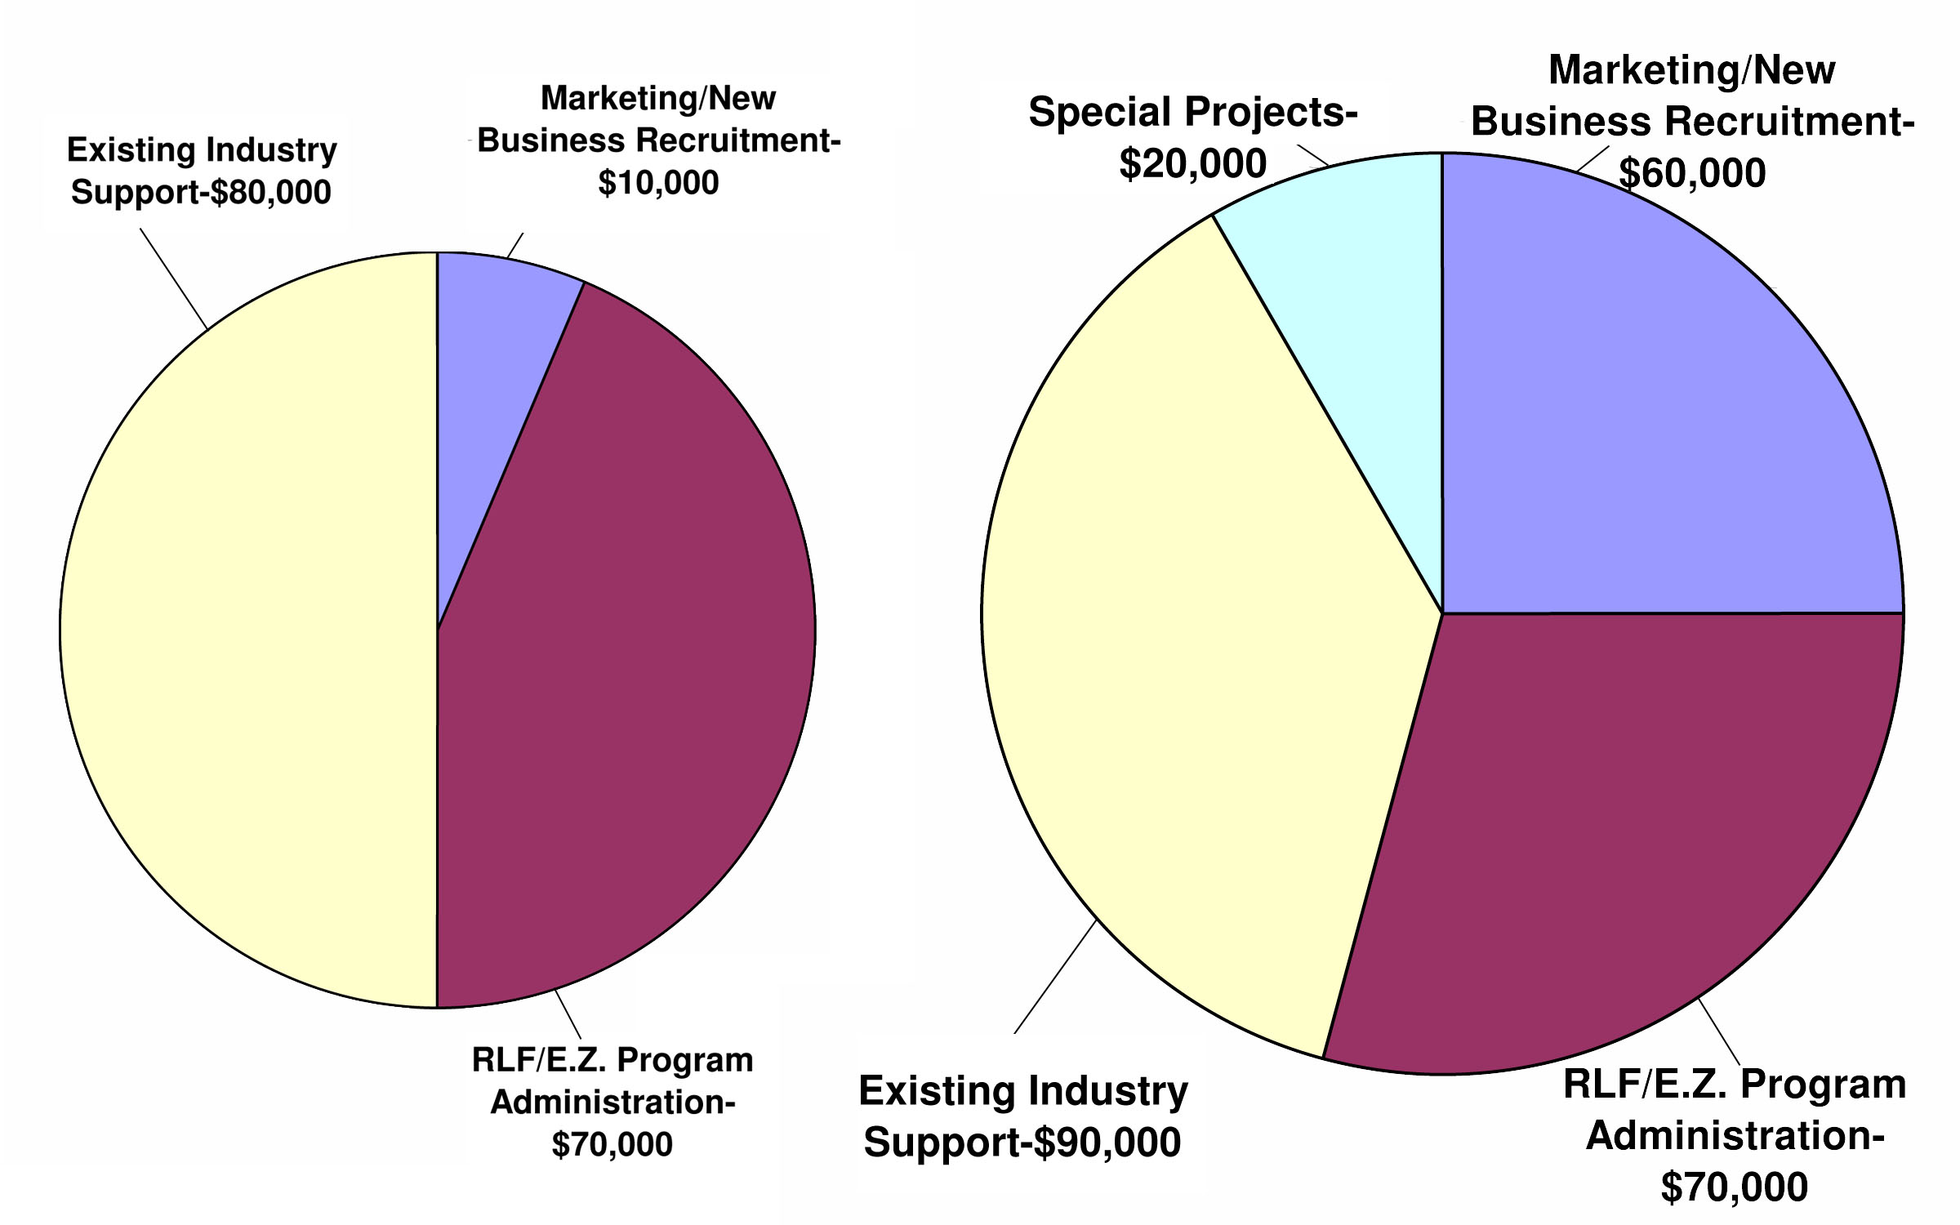
CURRENT
BUDGET ALLOCATION
PROPOSED
BUDGET ALLOCATION

INVESTOR RELATIONS

The goal of the investor relations program is to make every current investor, prospect, or potential investor an integral part of the CIC’s program.

COMMUNICATION

- Annual Investor Meeting – This meeting will detail activities and success-to-date, as well as, provide a forum to discuss short- and long-term plans.
- Investor Newsletter (Quarterly) – Update on specific topics of interest to investors.
- Fast E-mails (Periodic) – Hard hitting, bulleting style memos
- Visit the top 50 investors at least once per year
- Produce an annual report for all investors.

RECOGNITION

- Publicity in newsletter, marketing materials and articles.
- Company web-site link
- Involvement in hosting new business prospects.

OPPORTUNITIES FOR INPUT AND FEEDBACK

- Investor meetings.
- At least one personal contact per year for each investor.

PARTICIPATION IN PROGRAM INITIATIVES

- Serve as a task force member
- Serve as an ambassador to host receptions, tours etc. for prospects.
CIC ANNUAL SCORECARD

Existing Industry Program 2007 2008 2009 2010 2011
# of local company visits

# of expansion projects completed

# of expansion jobs created

# of existing jobs retained

Expansion capital investment

Expansion tax base increase

New Business Recruitment
# of trade shows attended

# of direct mailings

# of recruitment visits

# of prospect tours/site visits

# of companies located

# of new jobs created

Avg. wage of new jobs

New capital investment

New tax base created

CIC BOARD OF TRUSTEES

OFFICERS
Glenn Miller  President | John Sager  Vice President | Tricia Koesters Secy/Treasurer

TRUSTEES
Bruce Hesterman | Edward A. Hoeffel | Rich Myers
Kevin Nye | Israel Resendez | Richard Rickenberg
J. Andrew Small | Steve Small | Ted Titgemeyer
Terri Williams | Marlowe Witt

CIC STAFF

Lee Schroeder  Executive Director | Amanda Griffith  Administrative Assistant

